PLUGGING INTO THE FUTURE: AN EXPLORATION OF ELECTRICITY CONSUMPTION PATTERNS

INTRODUCTION :

* OVERVIEW :

Plugging into the future: An exploration of electricity consumption patterns. Through this project we understand the definition of electricity consumption patterns. Electricity is flow of electrical power or charge.

* PURPOSE :

The purpose of electricity consumption is important to measure of the country’s electric power development. People use electricity for lighting, heating, cooling and for operating appliances. This project gives idea to solve the future electricity problems and utilization of daily usage.

PROBLEM DEFINITION & DESIGN THINKING :

* EMPATHY MAP :

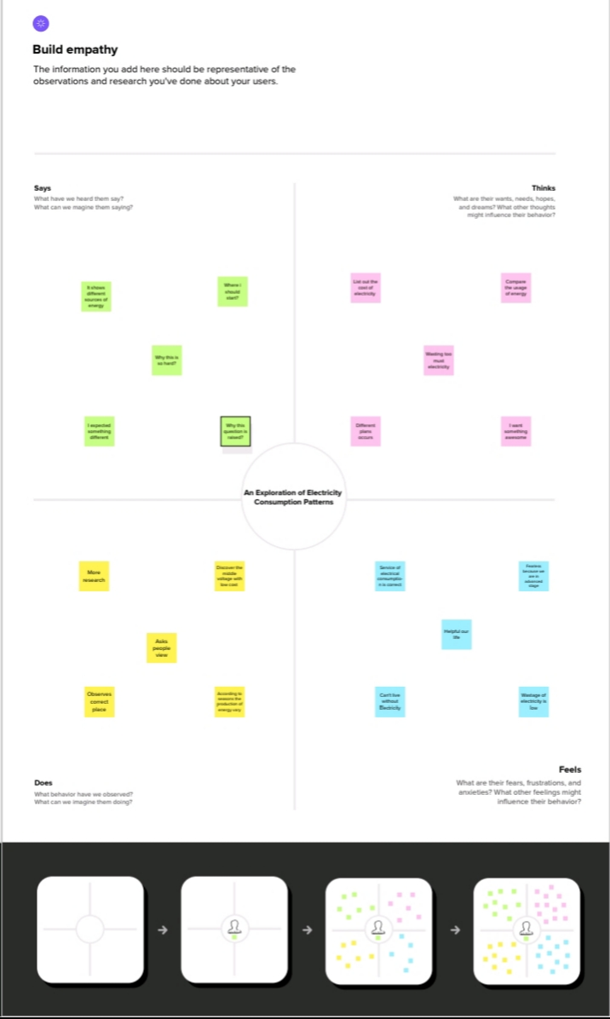

* IDEATION & BRAINSTORMING MAP:



RESULT :

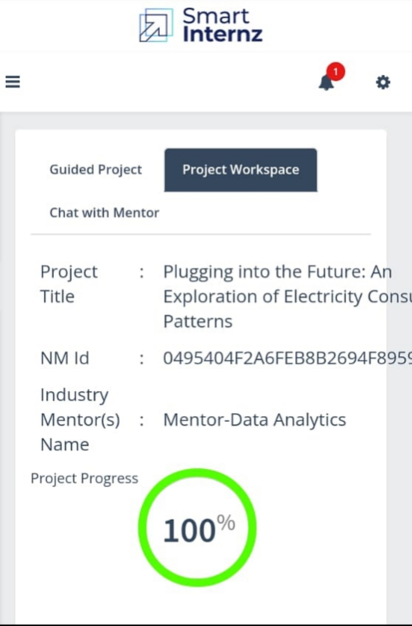

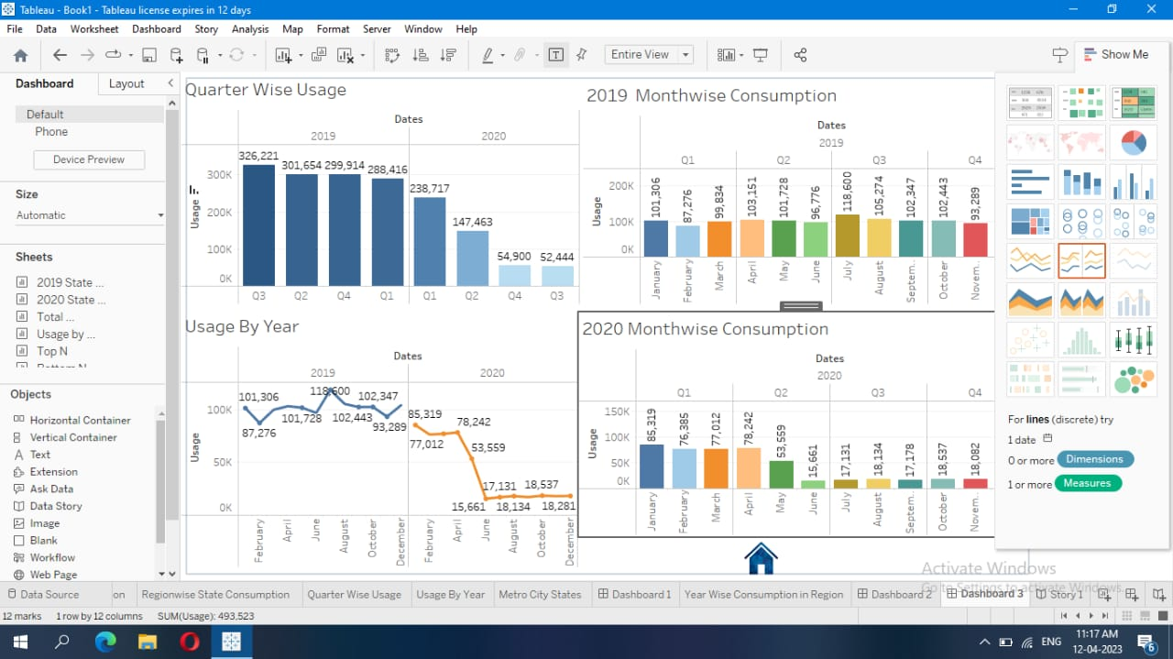

ADVANTAGES & DISADVANTAGES :

ADVANTAGE :

* It is a clean, safe, cheap and convenient source of energy.
* Lower maintenance cost.
* More efficient.
* No tailpipe emission.
* We all know that it can be set up in many sizes.
* It doesn’t require as many employees.
* Reduce greenhouse emission.
* Makes barely any pollution compare to other ways of creating or generating electricity.
* Relatively low maintenance cost.
* Hydroelectric station are inexpensive to operate.
* Hydroelectricity produces no gas emissions or waste.
* A station can operate and run for long periods of time.
* It is renewable.

DISADVANTAGES :

* More expensive than gasoline.
* Lose of fish species.
* Sometimes messes up wildlife.
* Dependent on precipitation.
* More power plants and more pollution.
* Damming can cause loss of land suitable for agriculture as well as recreation.
* Cost for construction.
* Change in river or stream quality.
* An electric vehicle is not completely emission free.
* In electricity, there are a limited number of feasible sites for a large number of dams.

APPLICATIONS :

Energy storage applications are used to meet peak power demands and high power switching in a short time. It is inevitable to use energy storage applications within advanced power systems. It is currently applicable for our daily life.

CONCLUSION :

Environmental: Increased efficiency can lower greenhouse gas (GHG) emissions and other pollutants, as well as decrease water use.

Economic: Improving energy efficiency can lower individual utility bills, create jobs, and help stabilize electricity prices and volatility.

Utility System Benefits: Energy efficiency can provide long-term benefits by lowering overall electricity demand, thus reducing the need to invest in new electricity generation and transmission infrastructure.

FUTURE SCOPE :

Energy conservation can be achieved in two different ways that include reducing the amount of primary energy consumed to supply the useful energy requirement and reducing the end point use of nonessential energy.

“THE KINGDOM OF HEAVEN IS LIKE

ELECTRICITY. YOU DON’T SEE IT. IT IS

WITHIN YOU.”

“SAVE ENERGY

SAVE ELECTRICITY”